23.46: a) 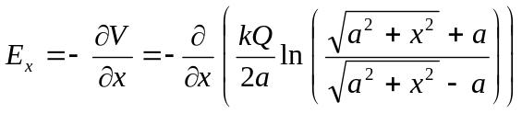
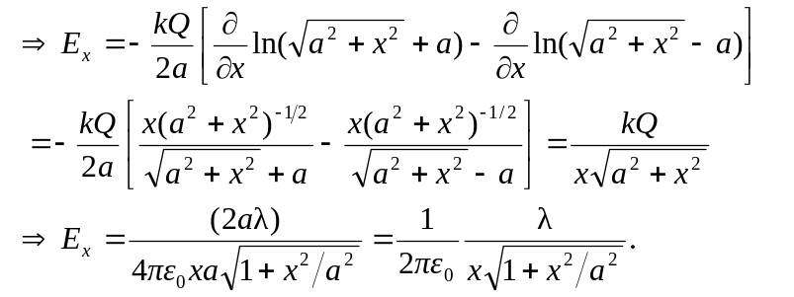

b) The potential was evaluated at y and z equal to zero, and thus shows no dependence on them. However, the electric field depends upon the derivative of the potential and the potential could still have a functional dependence on the variables y and z, and hence 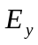 and 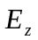may be non-zero.

